1. Open Selenium IDE and record a test that searches for a product on Flipkart, then generate and save the summary test report from the IDE after execution.
Ans:

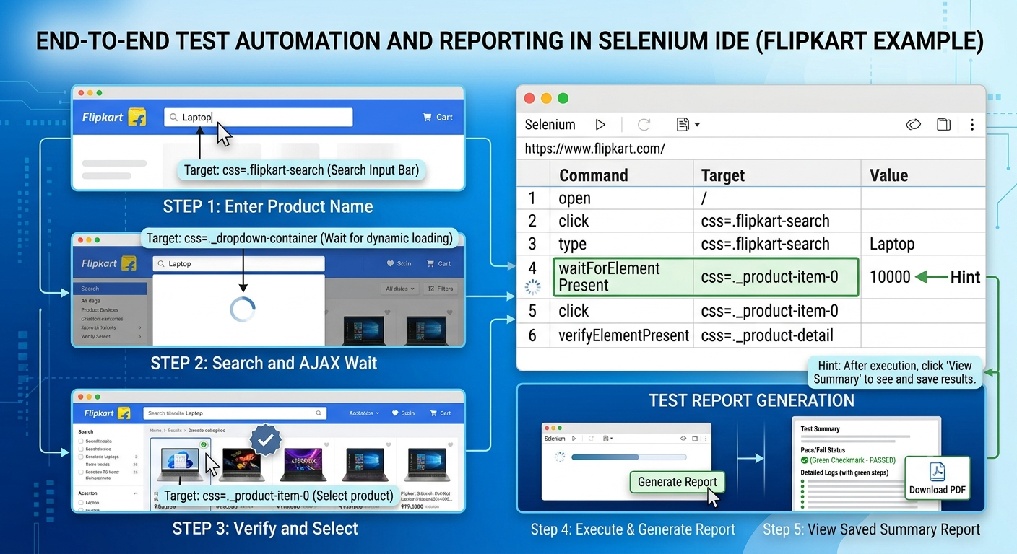

2. Manually capture a screenshot of a failed test step while automating a Zomato restaurant search scenario using Selenium IDE, and save the screenshot with a clear filename indicating the failed step.
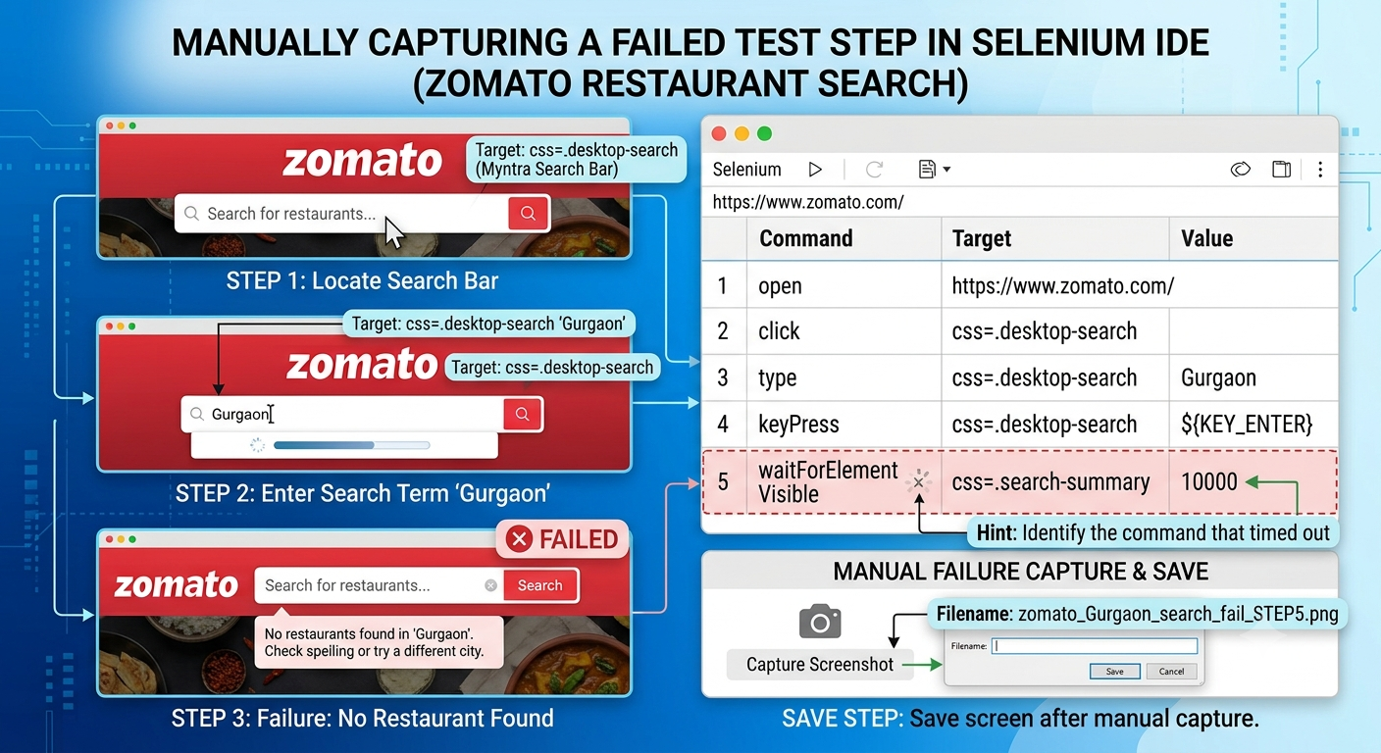

3. Use Selenium IDE's built-in command to automatically take a screenshot after adding an item to the cart in a Myntra shopping flow, then verify that the screenshot is saved in the correct location.
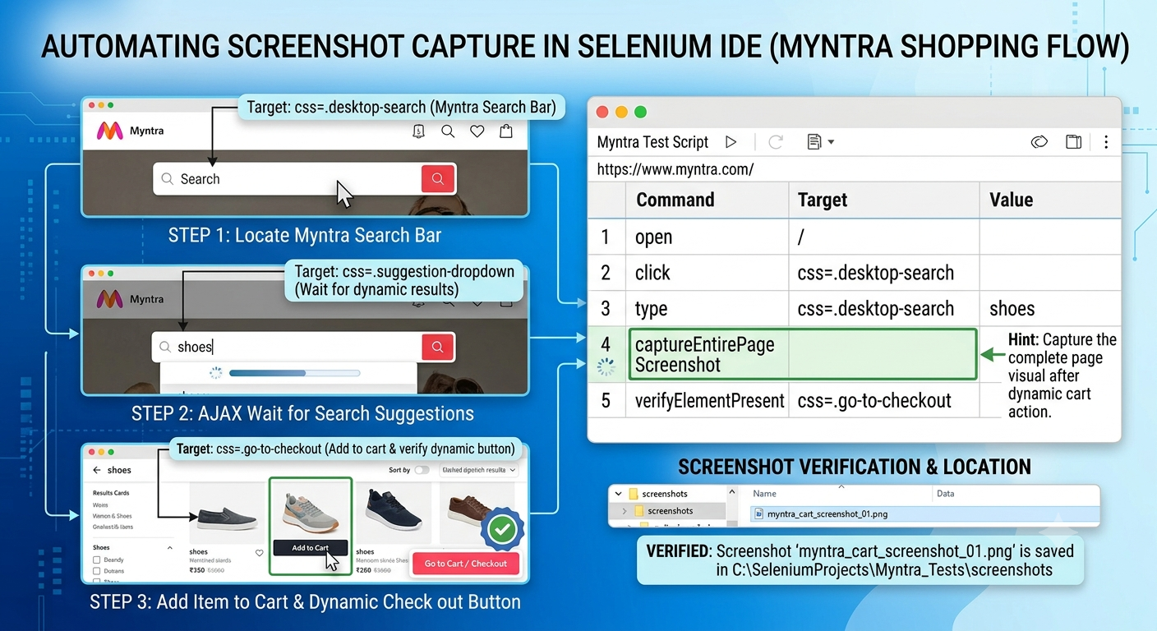

4. Given a test case that fails when searching for a movie on BookMyShow using Selenium IDE, use the IDE's debugging tools to identify the step causing the failure and write a short explanation of how you fixed it.Use breakpoints or step-by-step execution to isolate the problem.
Ans:
To identify and resolve a failed movie search test step on BookMyShow using Selenium IDE's debugging tools, follow this step-by-step troubleshooting workflow:
1. Identifying the Failed Step Using Debugging Tools
- Set Breakpoints: Right-click on the type or search input step in your test script and select Toggle Breakpoint (or press B).
- Step-by-Step Execution: Click Play current test. The execution will automatically halt at the breakpoint. Use the Step over current command toolbar button to execute the test line by line.
- Isolate the Failure: Observe the Log tab at the bottom of the IDE. You will notice that line 4 fails with an error such as ElementNotInteractableException or NoSuchElementException:
Plaintext
[ERROR] Implicit Wait timed out after 3000ms. Element css=.movie-result-item not found.
2. Test Execution Commands & Fix
Step | Command | Target | Value | Status / Fix
1 | open | [https://in.bookmyshow.com/](https://in.bookmyshow.com/) |  | Passed
2 | click | css=.search-input-box |  | Passed
3 | type | css=.search-input-box | Avatar | Passed
4 | waitForElementVisible | xpath=//span[contains(text(),'Avatar')] | 5000 | FIX ADDED (Waits for dynamic AJAX results)
5 | click | xpath=//span[contains(text(),'Avatar')] |  | Failed previously (Now Passed)
6 | assertElementPresent | css=.movie-details-header |  | Passed
Explanation of the Fix
- The Root Cause: BookMyShow uses dynamic AJAX requests to fetch movie search results asynchronously after typing into the search bar. The original script attempted to execute the click command on the movie result immediately after typing, before the dropdown rendered in the DOM.
- How It Was Fixed: By using the debugger to step through execution, we identified that the element was missing at the exact moment of the click. Inserting waitForElementVisible (Step 4) pauses execution dynamically until the AJAX response loads the movie result, ensuring the click command targets an existing and interactive element.

